A Project Report On

[Premium Store]

Submitted for the partial fulfillment of Project in
B.C.A. – 5th Semester [2025]


-:Submitted To:-

Department of Bachelor of Computer Application Harivandana College - Rajkot

-:Affiliated To:-


Saurashtra University, Rajkot
-: Submitted By :-
Umaretiya Anuj Mansukhbhai
(23SI002UG00201)

-: Under the Guidance of :-

Dr. Ashwin Rathod (Head of Department) Prof. Bhavesh Chavda (Project in Charge)

 | 2 | Premium store
 |  | 
 |  |  |  | No. | Description | Page No.
 |  |  |  | 1 | Preface | 3
 |  |  |  | 2 | Declaration | 4
 |  |  |  | 3 | Acknowledgment | 5
 |  |  |  | 4 | Project Profile | 6
 |  |  |  | 5 | Web Architecture | 7
 |  |  |  | 6 | Web Pages | 8
 |  |  |  | 7 | Introduction to HTML | 9
 |  |  |  | 8 | Introduction to CSS | 10
 |  |  |  | 9 | Introduction To JavaScript | 11
 |  |  |  | 10 | Introduction To PHP | 13
 |  |  |  | 11 | Introduction to MySQL | 16
 |  |  |  | 12 | System Requirement | 18
 |  |  |  | 13 | Cost and Benefit Analysis | 19
 |  |  |  | 14 | Fact Finding Techniques | 18
 |  |  |  | 15 | System Development Life Cycle(SDLC) | 20
 |  |  |  | 16 | Data Dictionary | 21
 |  |  |  | 17 | DFD Diagram | 26
 |  |  |  | 18 | Admin Panel webpage | 30
 |  |  |  | 19 | Client panel webpage | 36
 |  |  |  | 20 | About Testing | 47
 |  |  |  | 21 | Bibliography | 49
 | Umaretiya Anuj

3 ffpremium store



We have tried to include different menus and pages. In different categories like sofa, bed, table and chair. We also include Contact & Feedback about our Collection website. This site would be help to consuming the time and easy to order through contact no or Branch address.
The trend of shopping on the internet has been constantly increasing all over the world. Primary data was collected in administering the survey. Through the survey we found that genuineness, guarantee and price are the primary factors all products consider while shopping online.

4 PPremium store




We are the student of B.C.A sem-5 hereby declare that the project work presented in this folio is my contribution and have been carried out under supervision of all professors of B.C.A Department of Harivandana College, Rajkot.
The main objective of this training undertaken is to get specialized knowledge in a particular specialized field, which further sharpen the skill and also include that it is a part of our studies undergoing.
This work has not been previously submitted to any other institute/university for any of the purposes.

Place: Rajkot Date: 15/10/2025
Thank You,

Umaretiya Anuj

5 Premium Store




We are the student of B.C.A studying in the Harivandana College-Rajkot. Thanks, the entire person who has landed their support in shaping of the systemic
We thank Mr. Bhavesh Chavda before giving us full guidance and cooperation in understanding the system. we also thank them for their unconditional help in making of this project.
We have great deal of gratitude to wards our Head Of Department who encourage us in taking up this activity. we thank all faculties and administrative staff of the institute in enhancing their cooperation.

6 Premium Store




Project Title | : |  | Premium Store
Developed At | : | Harivandana College – Rajkot
Prepared By | : | Umaretiya Anuj
Main Pages | : | Home page (Home)
Operating System | : | Windows 11.
Web Server | : | Apache Server(localhost)
Web Browser | : | Internet Explorer 6. 0, Mozila Firefox, Google Chrome, Opera.
Editor | : | Visual studio code, Notepad
For Internet Access | : | 486 D*2 or Higher Processor.  Free Disk Space 200 MB.  Color Monitor & Multimedia Kit. One Free comport For Modem. Modem 56 Kbps.
Guided By | : | Mr. Bhavesh Chavda
Submission At | : | BCA Department of Harivandana College.





7 Premium store
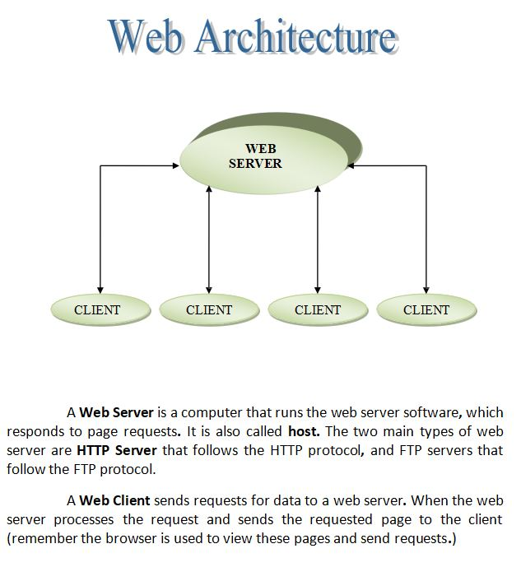
8 Premium Store


The big attraction with active server pages, of course is the ability to include script directly in the file that’s referenced by the browser, and that creates dynamic pages.
It’s important to recognize how ASP differs from existing methods such as refining a latest page, executing CGI and ISAPI applications or running traditional scripts.
There are two types of web pages that are as under:
- Static Web Pages
- Dynamic Web Pages

Static Web Pages:
When the user enters URL into their browser’s address box, or clicks a hyperlink on another page, a request for that page is sent to the server. This is just a file on the server’s hard disk, and the web server software starts by loading it into memory. If it’s a normal static HTML page, the server adds a few transmission protocol requirements such as the document type, encodes it so that it can be transmitted over HTTP, and sends the whole thing to the browser.
The user sees the contents as rendered HTML page, but the same source is the same is the file that is stored on the server’s disk.

Dynamic Web Pages:
To create a dynamic web page using traditional methods, the server has to do more than just package up and send a file from disk. If the request from the browser is for a CGI or ISAPI application file, the server loads application & executes it. The application itself creates a stream of text HTML code, just like if was sending it to a printer. This is assembled in to a temporary page on the server, packaged up for HTTP transition, and sent to the browser. To the user, it looks just like a normal static page, because it’s still just HTML code. However, the actual page is no longer just a copy of the file on the server’s disk. It is created on the fly, and the page can be refreshed. Each time the application
that creates it is refreshing.

9 Premium Store



Understanding HTML :

- HTML was originated by Tim Berners-Lee.
- HTML developed a few years ago as a subset of SGM (Standard Generalized Mark-up Language), which is a higher-lever mark-up language that has long been a favorite of the Defense .
- Any HTML document is also valid for SGML .
- HTML is a Hyper Text Markup Language that is used to develop web pages .
- HTML is not a programming language like C , C++ and Java etc.
- It is a cross platform markup language that is design to be flexible enough to display text and other elements like graphical on a variety of views.
- The HTML document Consist of special Tags that are embedded in an ASCII document .
- Web browser like Internet Explorer, Netscape Navigator etc, interprets these Tags.

10 Premium Store



Definition of CSS:
CSS stands for Cascading Style Sheet. CSS are a series of instruments that specify how text should appear on web pages. you can use CSS to set styles for text, font, border, list and background.

Advantages of CSS:

- CSS save Time
When most of us first learn html, we get taught to set the font, face, size, color etc. every time is wasted with CSS, you occur on a page. that time is wasted with CSS you only occur have to specify these details once for any elements.

Pages Load Faster
Less code means faster download times.

Easy Maintenance
To change the style of an element, you have only to make an edit on one place.



11 Premium Store

Definition :

A scripting language for web pages. Scripts written with JavaScript can be embedded into HTML documents. JavaScript is an interpreted language means that scripts executed without preliminary compilation.

Introduction :

JavaScript is Netscape's cross-platform, object-oriented scripting language. JavaScript is a small, lightweight language; it is not useful as a standalone language, but is designed for easy embedding in other products and applications, such as web browsers. Inside a host environment, JavaScript can be connected to the objects of its environment to provide programmatic control over them.
JavaScript can function as both a procedural and an object-oriented language. Core JavaScript contains a core set of objects, such as Array, Date, and Math, and a core set of language elements such as operators, control structures, and statements.

Features of JavaScript:
JavaScript is becoming increasingly important,and it remains the ost broadly available scripting language for Web development. The features of java script are as follow:

Higher-order functions:
A high-order function is one that either takes functions as arguments or returns a function. This feature lets java script programmers manipulate functions in ways that the Java language can't.

Dynamic typing:

By delaying binding, JavaScript can be more concise and flexible.

12 Premium Store

A flexible object model.

JavaScript's object model uses a relatively uncommon approach to inheritance called prototypes instead of the Java language's more common class-based object model.

Advantages of JavaScript:

  - JavaScript gives HTML designers programming tools.
  - JavaScript can put dynamic text into HTML pages.
  - It can react to events.
  - It can read and write HTML elements.
  - It can be used to validate data.
  - It can be used to create cookies.
  - It can be used to detect the visitor’s browser.

13 Premium Store

The full form of PHP is “Hypertext Preprocessor”. Its Original name was “Personal Home Page”

Rasmus Lerdorf software engineer, Apache team Member is the creator and original driving force Behind PHP. The first part of PHP was developed For His personal use in late 1994.
By the middle of 1997. PHP was being used on Approximately 50,000 sites worldwide.

PHP is server – side scripting language, which can be Embedded in HTML or used as a stand – alone.

PHP doesn’t do anything about what a page looks and sounds like. In fact
, most of what PHP does is Invisible to the end users.
Someone looking at a PHP page will not necessarily Be able to tell that it was not written purely in HTML, because usually the result of PHP is HTML.

PHP is an official module of Apache HTTP server.

PHP is fully cross-platform, meaning it runs native on several flavors of UNIX, as well as on windows and now on Mac OS.

Advantages of PHP:

PHP is one of the most popular server-side scripting languages running today. It is used for creating dynamic Webpages that interact with the user offering customized information. PHP offers many advantages; it is fast, stable, secure, easy to use and open source (free). Following is the strength of PHP.

Premium Store
14

Operating System:
PHP can be used on all major operating systems, including Linux, many Unix variants (including HP-UX, Solaris and OpenBSD), Microsoft Windows, Mac OS X, RISC OS, and probably others.

Web servers:
PHP has also support for most of the web servers today. This includes Apache, Microsoft Internet Information Server, Personal Web Server, Netscape and I Planet servers, Oreilly Website Pro server, Caudium, Xitami, OmniHTTPd, and many others.

Programming way:
User also have the choice of using procedural programming or object- oriented programming, or a mixture of them.

Database:
One of the strongest and most significant features in PHP is its support for a wide range of databases. Writing a database-enabled web page is incredibly simple. The following databases are currently supported:

Adabas D | InterBase | PostgreSQL
Dbase | FrontBase | SQLite
Hyperwave | MySQL | Velocis
IBM DB2 | ODBC | Unix dbm
Hyperwave | MySQL | Velocis

Synchronization with HTML:
PHP code is inserted directly into the HTML that makes up a website. When a visitor comes to the website, the code is executed.

- Premium Store

Because PHP is a server side technology, the user does not need any special browser or plug-ins to see the PHP in action.

Simplicity:
The beauty of PHP lies in its simplicity. It is easy to understand and learn, especially for those with backgrounds in programming such as C, JavaScript and HTML.

Security:
PHP offers many levels of security to prevent malicious attacks.
These security levels can be adjusted in the .in file.

Community support:
A huge advantage that PHP offers is its community. Since PHP is an open-source project, the PHP community is willing to share. If anyone is looking for a particular script, chances are another user has already created.
16 Premium Store



What is My SQL?
MySQL is an open-source relational database management system(RDBMS) that uses Structured Query Language (SQL), the most popular language for adding, accessing, and processing data in a database.

Features:

Portability:
MySQL runs on almost every flavor of Unix, as well as Windows and MacOS X. User can obtain binaries or source code for the MySQL server as well as the tools that access it. More ports of the software become available every day. It is almost a given that MySQL will run on all Os.

Speed:
Using techniques such as efficient indexing mechanisms, inmemory temporary tables, and highly optimized join algorithms, MySQL executes most queries much faster than most other database systems

Scalability:
Because of its modularity and its flexibility in configuration, MySQL can run in systems varying in size from embedded systems to large multiprocessor Unix servers hosting databases with tens of millions of records.

17 Premium Store

Flexibility:
MySQL lets user to choose the table types that they need to meet their Software’s requirements, ranging from in-memory heap tables, faston-disk MyISAM tables, merge tables that group together other sets of tables to form larger “virtual” tables, and transaction-safe tables

Ease of use
MySQL is easy to install and administer. While other database systems require special knowledge and training, not to mention special operating system configurations, MySQL can be installed in less than 10 minutes if user has done it before MySQL requires little maintenance and administration other than adding or changing user permissions and creating or removing databases

Relational Database System:
Like almost all other database systems on the market, MySQL is relational database system.

Client/Server Architecture:
MySQL is a client/server system. There is a database server (MySQL) and arbitrarily many clients (application programs), who communicate with the server; that is, they query data, save changes, etc. The clients can run on the same computer as the server or on another computer (communication via a local network or the Internet).

Limitation:
In using MyISAM tables, MySQL is not able to execute hot backups, which are backups during operation without blocking the tables with locks. Here again, the solution is InnoDB, though here the hot backup function is available only in the form of a commercial supplement.

Many database systems offer the possibility of defining custom data types. MySQL does not support such functionality, nor is any currently planned.

18 Premium Store

It specified minimum requirement of any project . It contain hardware and software requirements of project. The detail about minimum system requirement in this project as given bellow .

Platform (Software):
Windows XP Windows 98
Windows any other platform

Front End And Back End Tools (Software):

Front End Tools:
  - HTML
  - PHP

Back End:
    - My SQL

Hardware Requirement Specification:

512 MB RAM.
PHP : Version 7.3 or Greater
MySQL version 5.0.15 or grater or any version of mariaDB WEB server –Apache.

19 Premium Store



Feasibility Study:

Feasibility study provides us information about cost of our project. This work on three-feature technical, economical, operational feasibility study.

Technical:
Technical feasibility check the project is technically possible or not. Technical feasibility can work for the project to be done with current equipment, existing software technology & available personnel. There is need for new technology.

Economical:
Economical Feasibility check, there are sufficient benefits to creating the system. It determines costs and expected of each of the alternative

Operational:
Will the system be used if it is developed & implemented?
Will there be resistance from user that will undermine the possible application the possible application benefits?

20 Premium Store



The analysis doesn’t know the working process of the user for which, he is going to develop information system. The analyst use specific methods for collecting data about requirement, which is called fact-finding technique.

It includes the interview, questionnaire and record review. Analyst employees more than one of these techniques to help an accurate and comprehensive investigation. Analyst requires progressive lower level of detail for logical design. Hence it is also true that two project are never same in am information system. It means that analyst must use information-gathering tool.

Interview:
This is technique is used to collect information from individual or from groups. It is an art better learned from practice than books. It is an individual technique to gather qualitative information, opinions, policies, suggestion, underlying problem etc.

Questionnaires:
This technique is used to collect information from large number of people. Questionnaires give to every person and they fill Questionnaires. According to their answer decision are taken.

Record Review:
A good analyst gets facts from documentation. An existing system can be better understood by examining existing documents, forms and files. This record review can take place at beginning of the system study or letter in the study for comparing actual operation with what the records indicates.

Observation:
Observation can bring in missed facts, new ways to improve the existing procedures, duplicate work done inadvertently etc. Observation provides close view of working of real system. This task is delicate because people do not like to be observer when they work.





Premium Store
21


- Analysis
- Design
- Coding
- Testing
- Evaluation

In this planning and scheduling forward and backward steps are given which indicates the system study again during another work of project.

This diagram gives information about day scheduling information in our project.

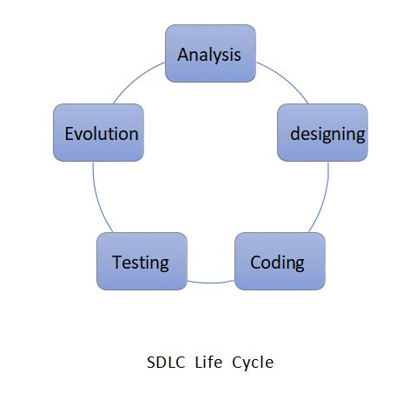

 | 22 | Premium Store
 |  |  | Feasibility
 |  |  | Study
 |  |  |  | Require-
 |  |  |  | Ment
 |  |  |  | Specifica-
 |  |  |  | Tion
 |  |  |  |  | Design
 |  |  |  |  |  | Description
 |  |  |  |  |  |  | Implemen-
 |  |  |  |  |  |  | tation
 |  |  |  |  |  |  |  | Documan-
 |  |  |  |  |  |  |  | Tation
 |  |  | 10 Days | 10 Days | 10 Days | 20 Days | 10 Days | 5 Days
 | Umaretiya Anuj

23 Premium Store


Data dictionary is the center responsibility of information about system and Organization. Data dictionary contain a list of tream and their meaning for all data items and data storages of the system.

Show tables:
: products :

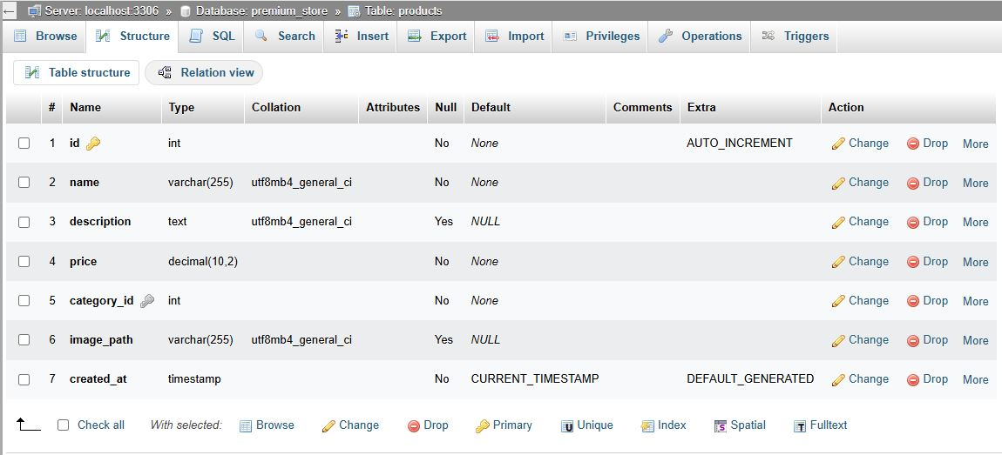

Premium store
24

:users:

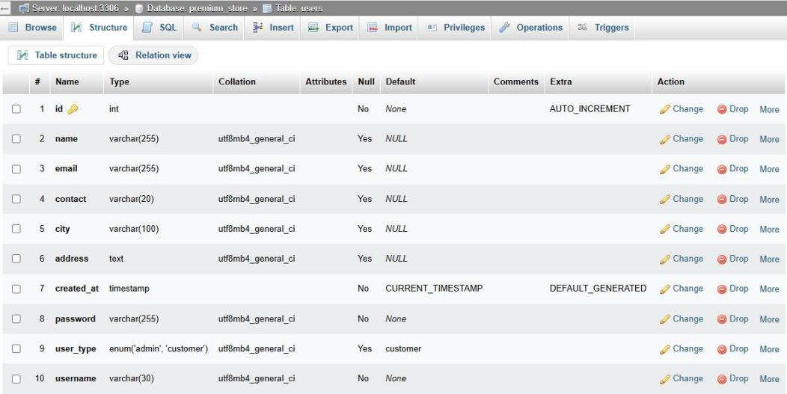

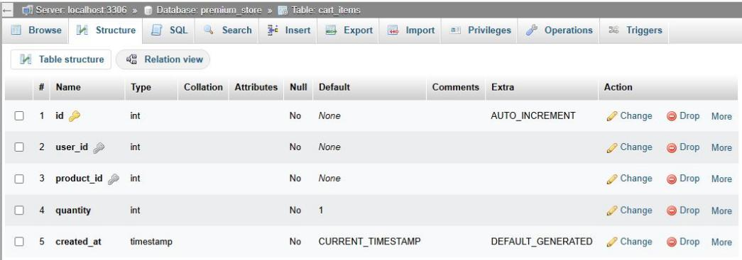
: Cart_items:

: Categories:
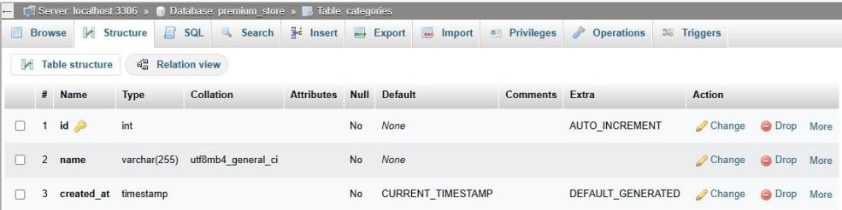
25 Premium Store
:Contact_messages:
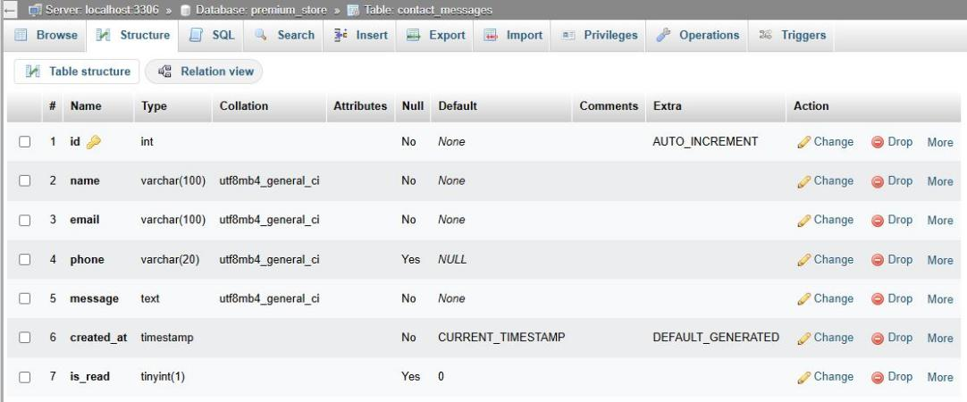

:Orders:

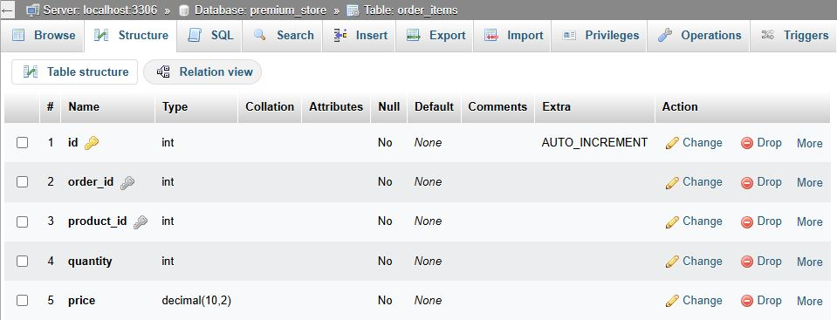

:Order_items:

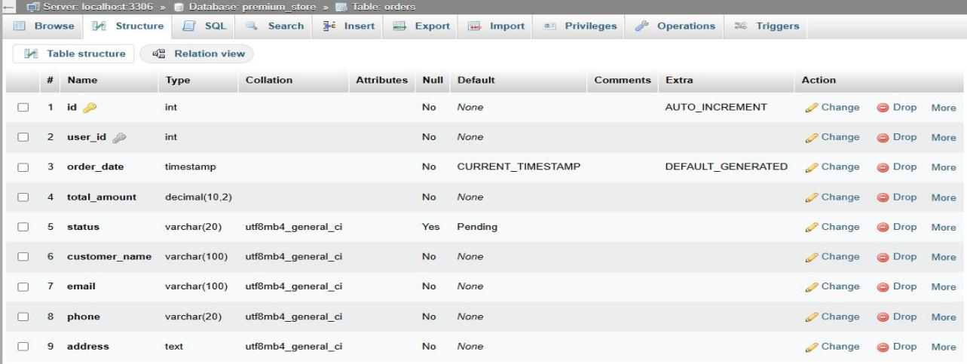
26 Premium Store

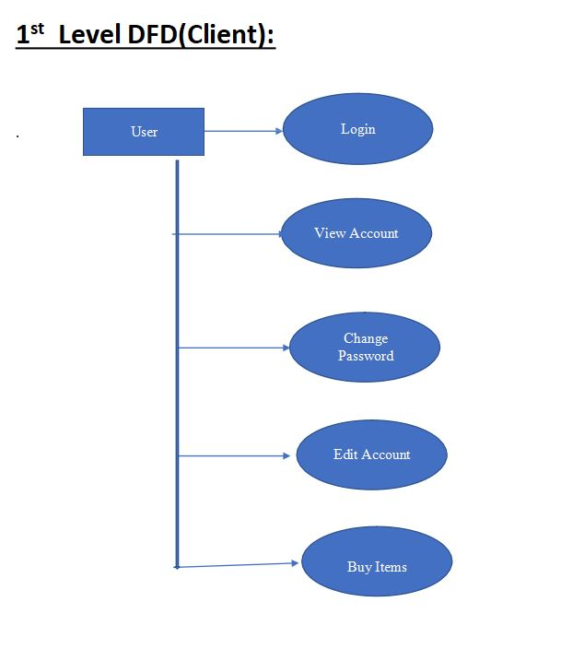Premiuum store
User
27

User

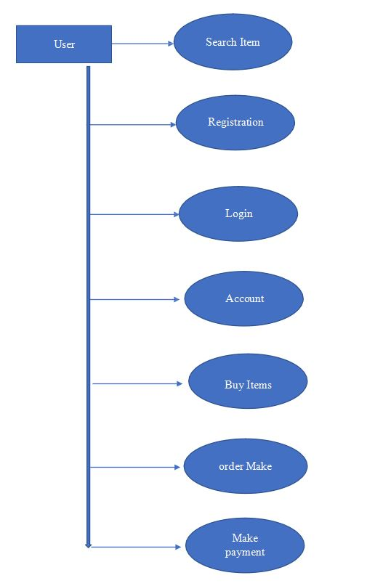
Buy Items
order Make
Premium Store
28

1st Level DFD(Admin):
.Login
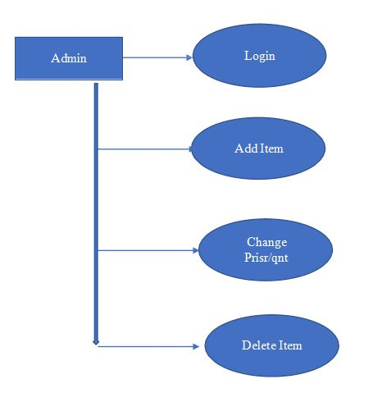Add Item
Admin
Change Prisr/qnt
Delete Item

29 Premium Store

0 Level DFD(Admin):
Admin

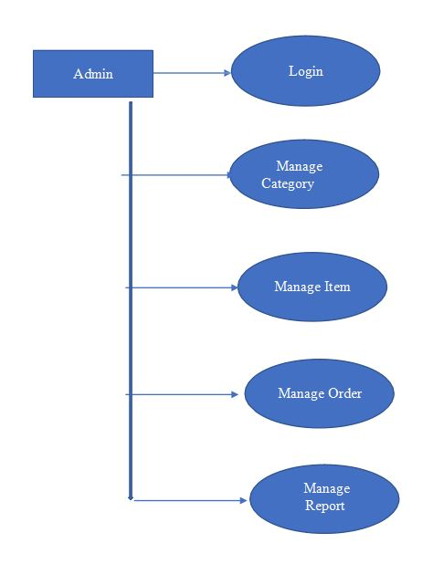
.
Manage der
t


30 Premium Store




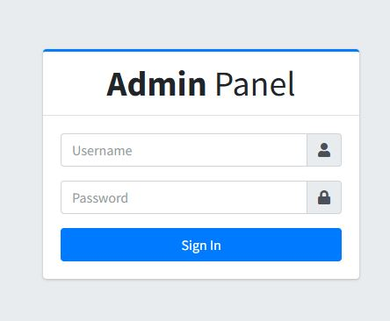
Premium Store

Admin Homepage:
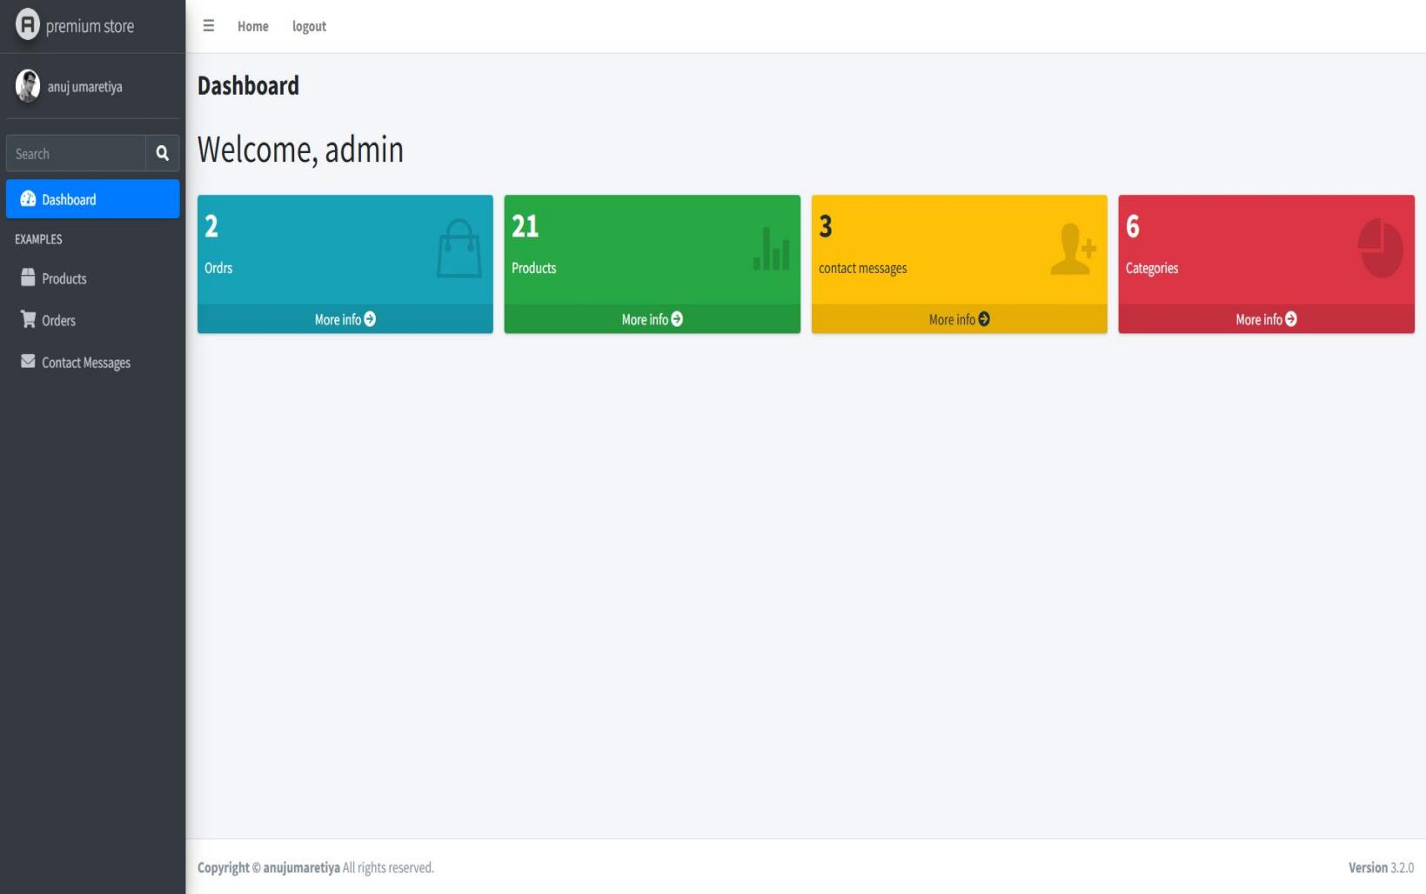
Category:
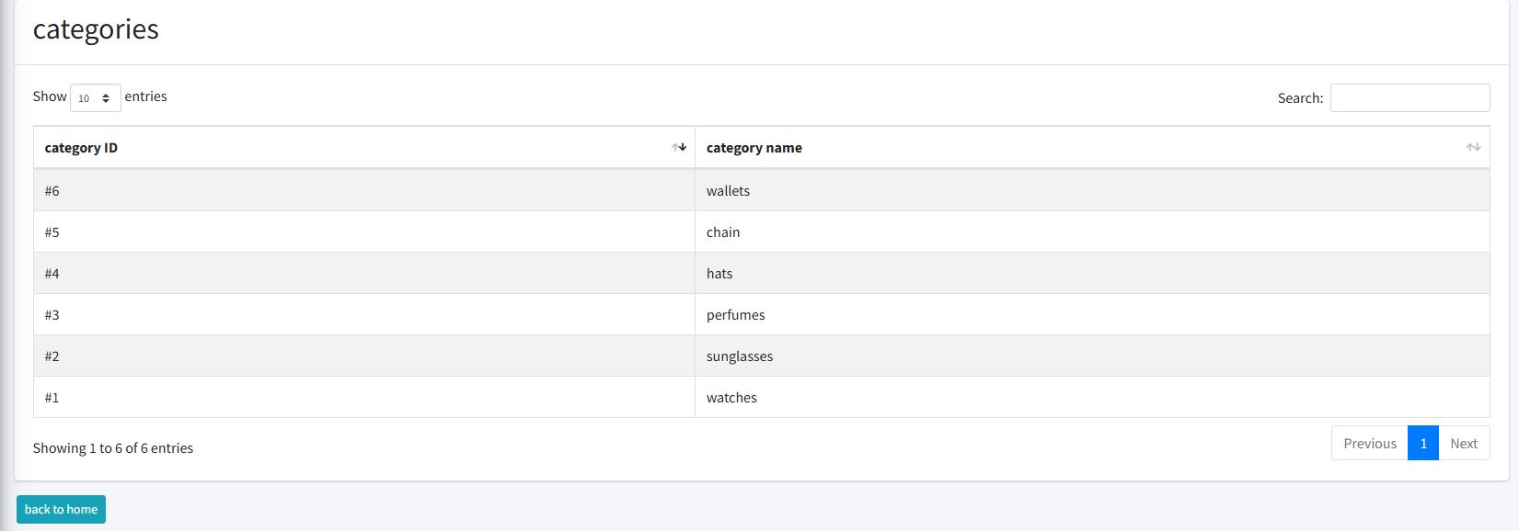
Premium Store
31

Premium store
32

Orders:

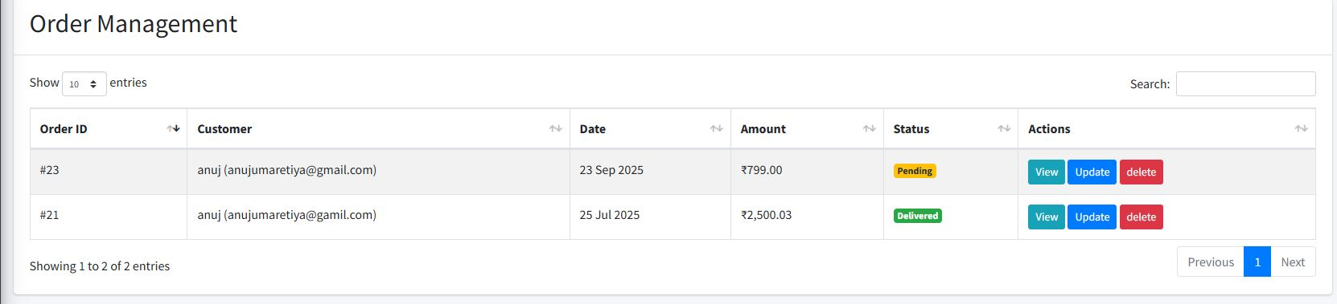

View orders details:
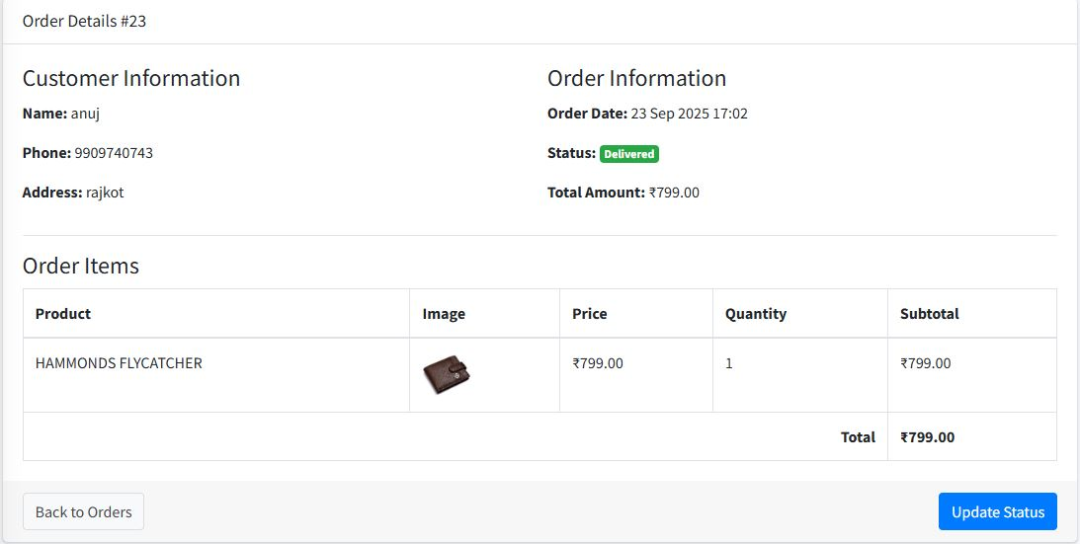
premium store
33

update order:
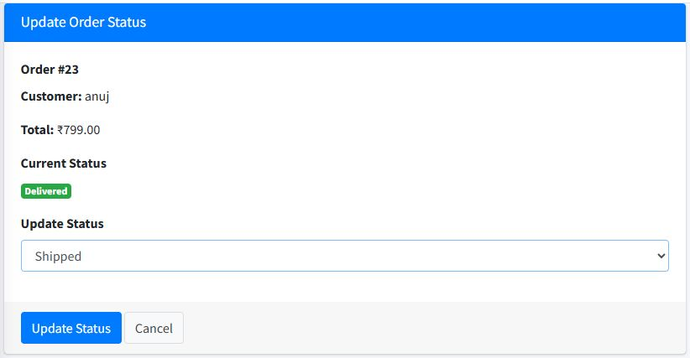

contact messages:

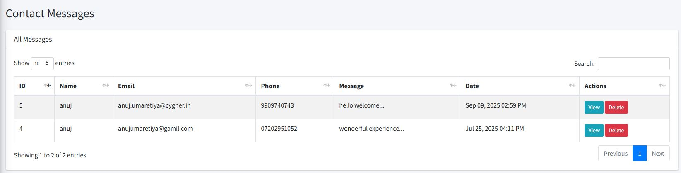
34 ffpremium store

view contact messages:

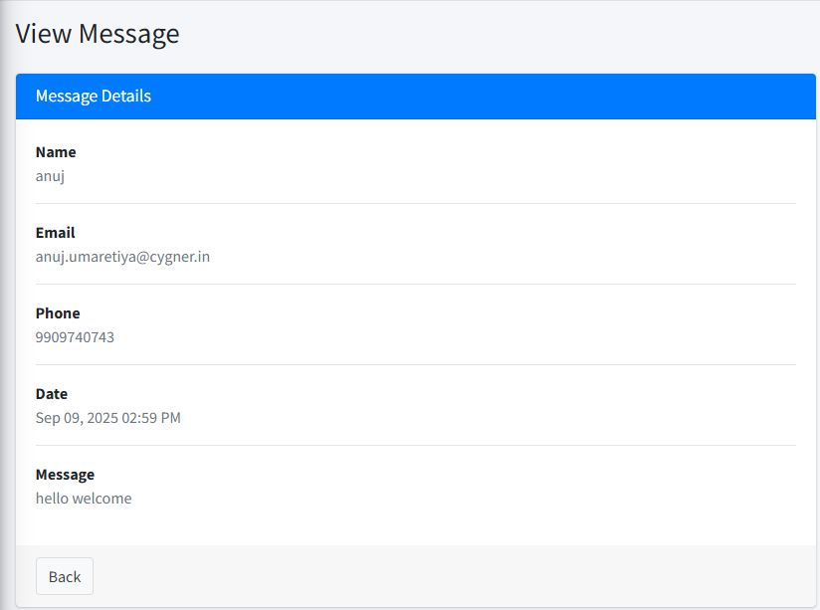
Premium store

Products:

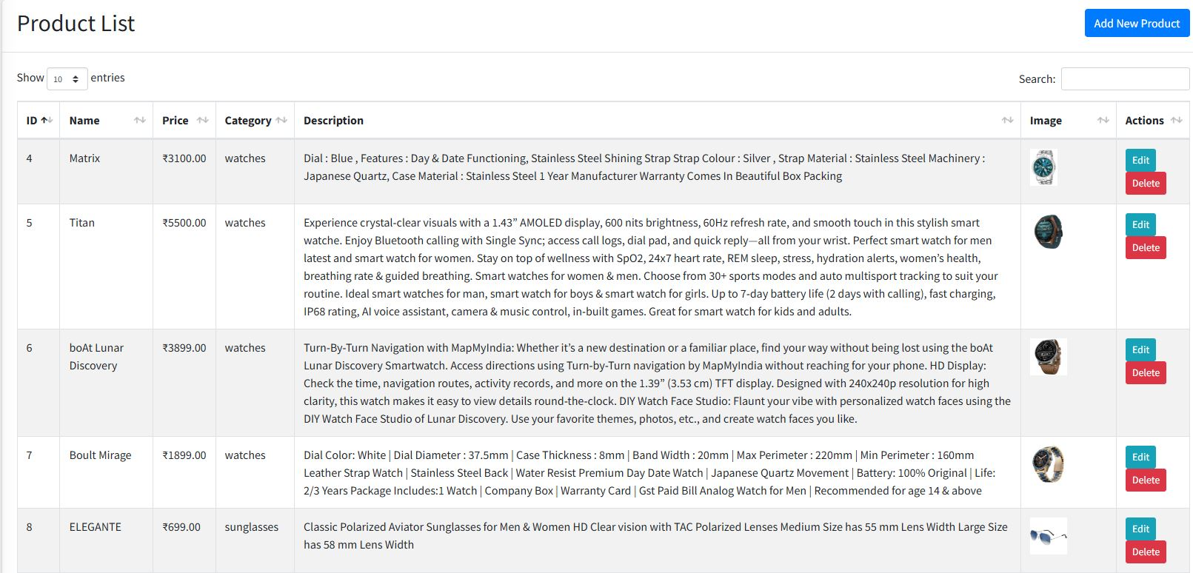

35
Premium Store
36 Premium Store





- Home page
- Categories
All
  - watches
  - glasses
  - perfumes
  - hats
  - Chains
  - wallets
- About us
- Login
- Contact
- Register
- Cart checkout bill

Home Page

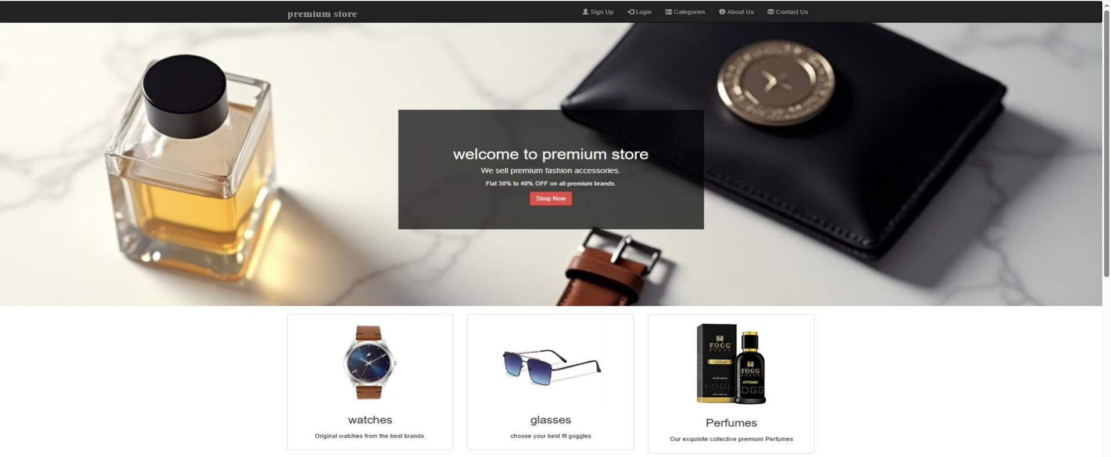
Premium Store
37

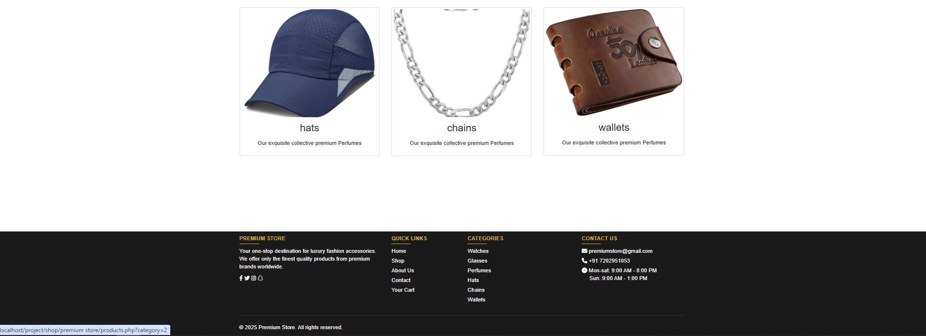

Login
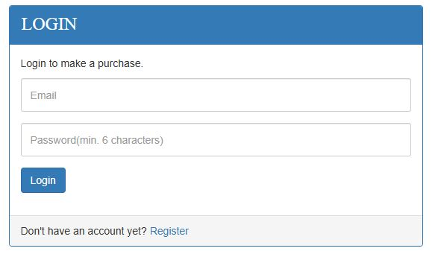

Premium store

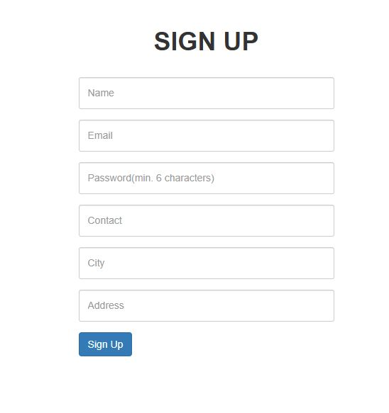
Register
38
Premium Store
39

Contact us

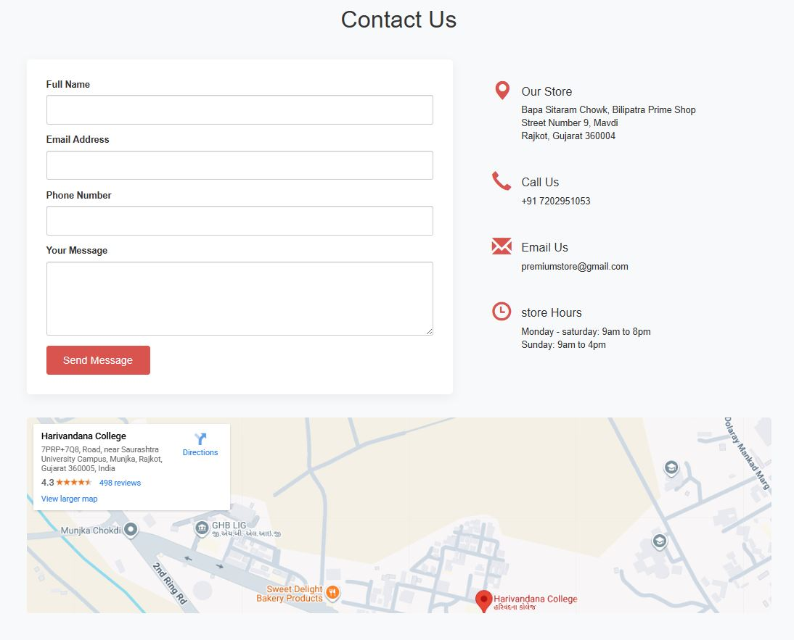

Premium store
40
About us:
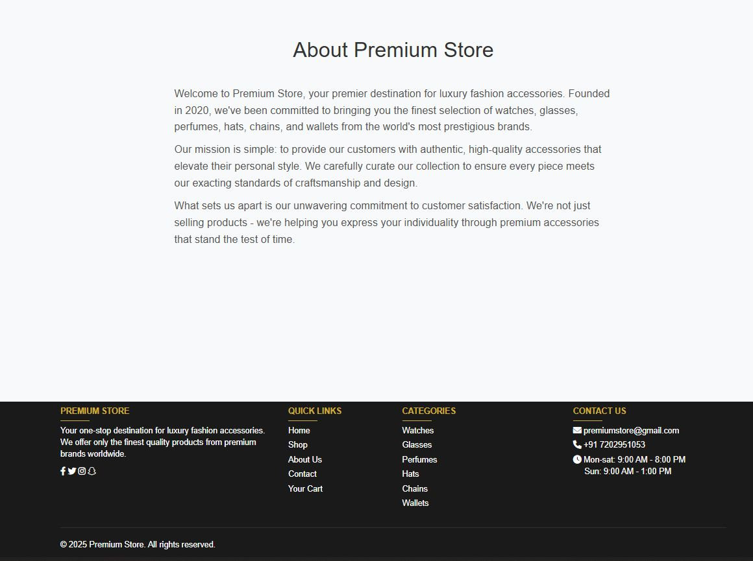
41 Premium Store
Categories:

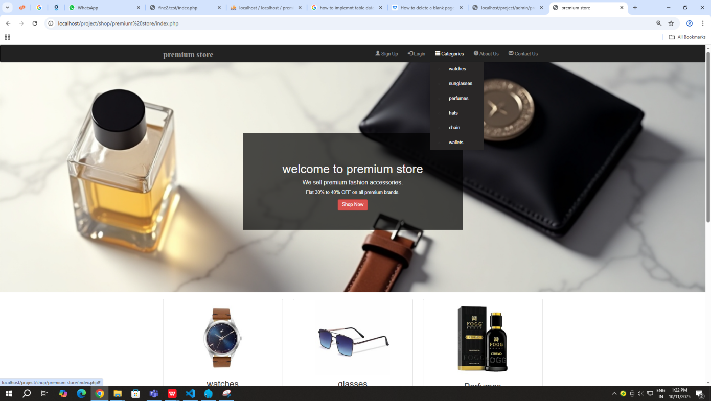

watch:

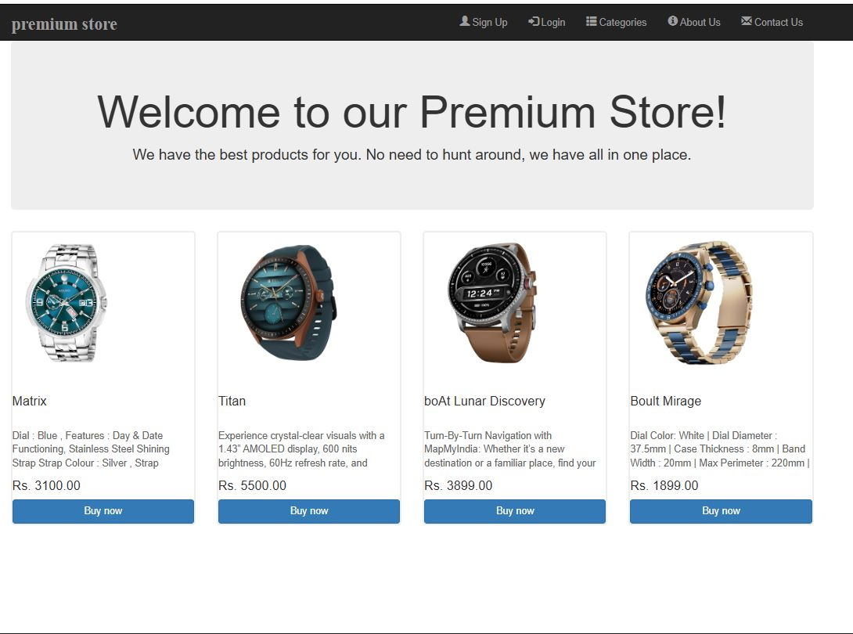

Premium Store
42

Glasses:
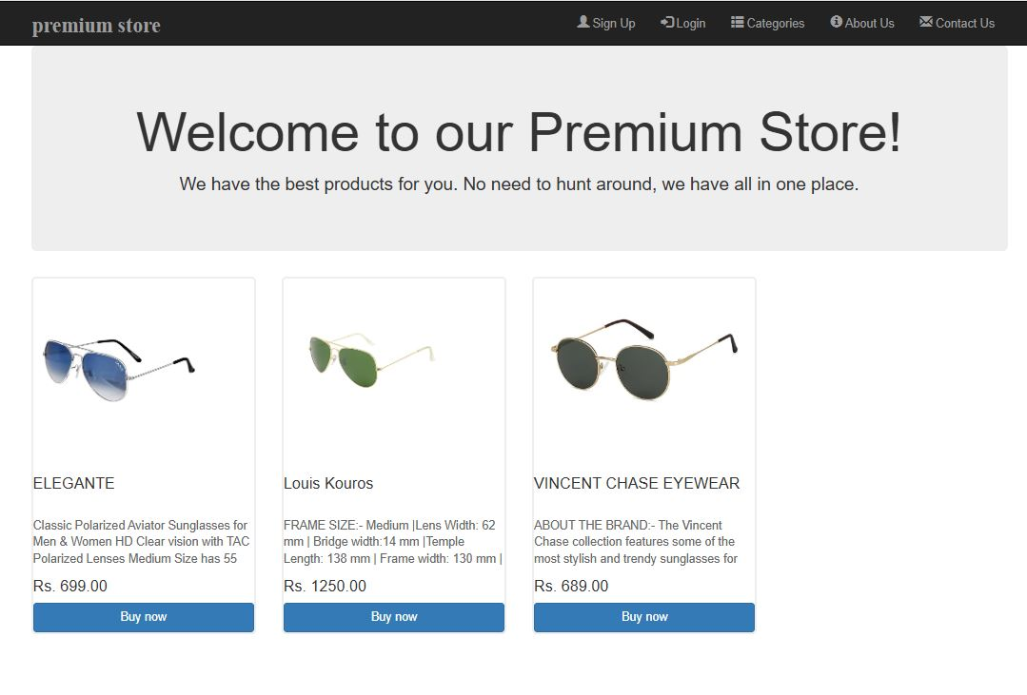
Perfume:

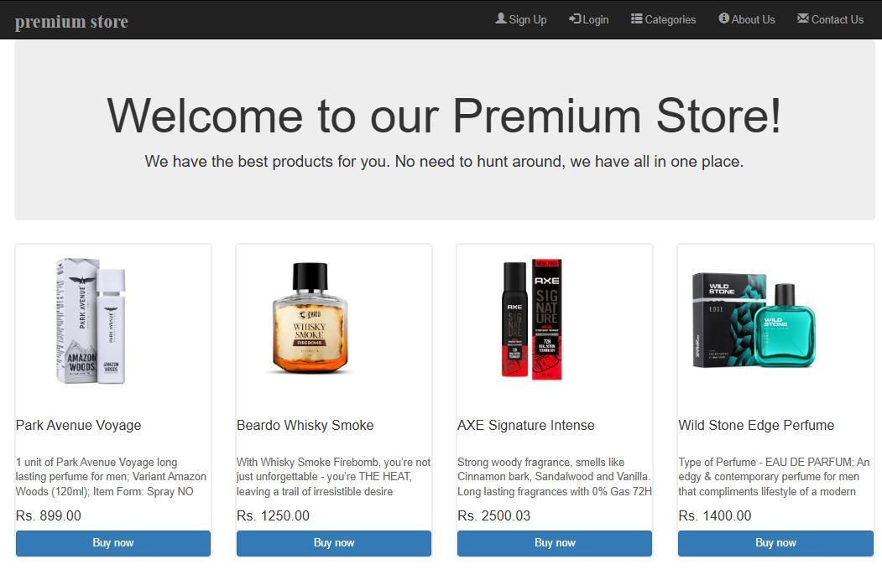

43 Premium Store
Hats:

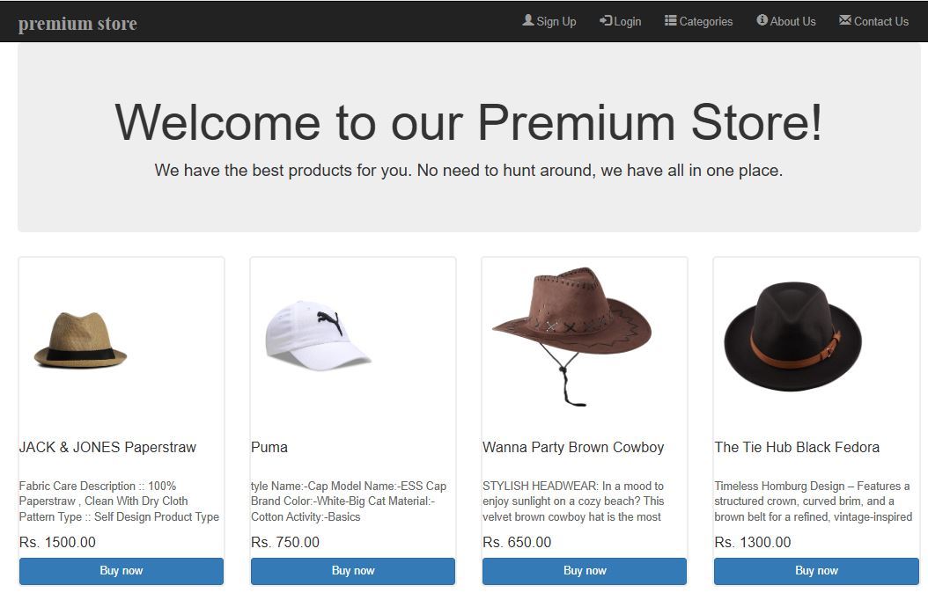
Chain:

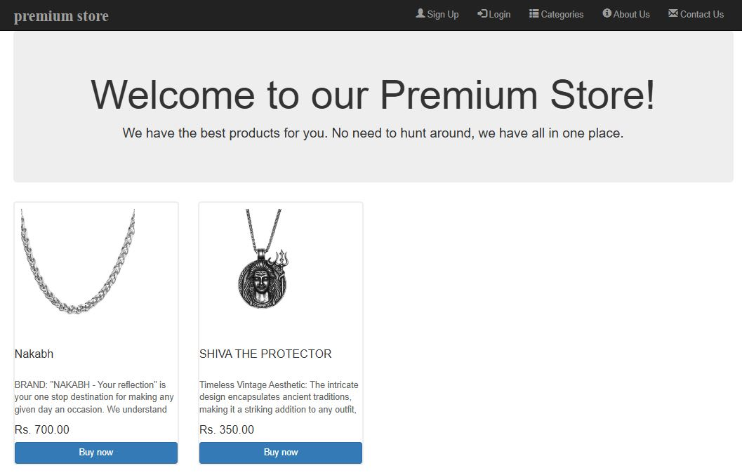

44 Premium Store
Wallet:

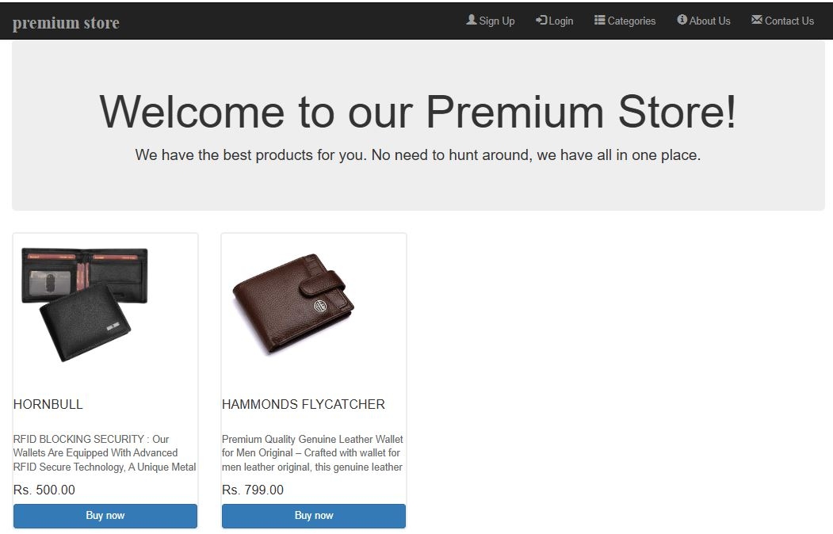
Cart:

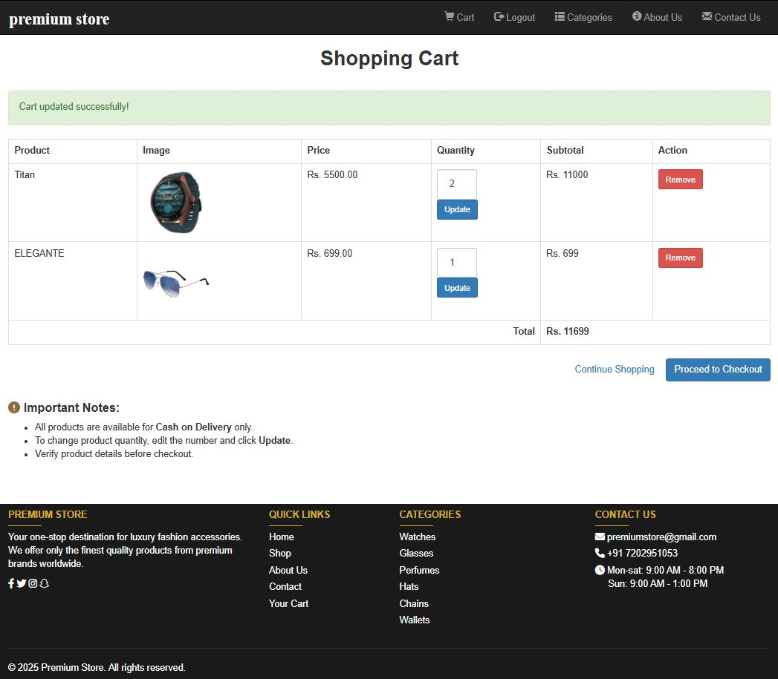
45 Premium Store
Checkout:
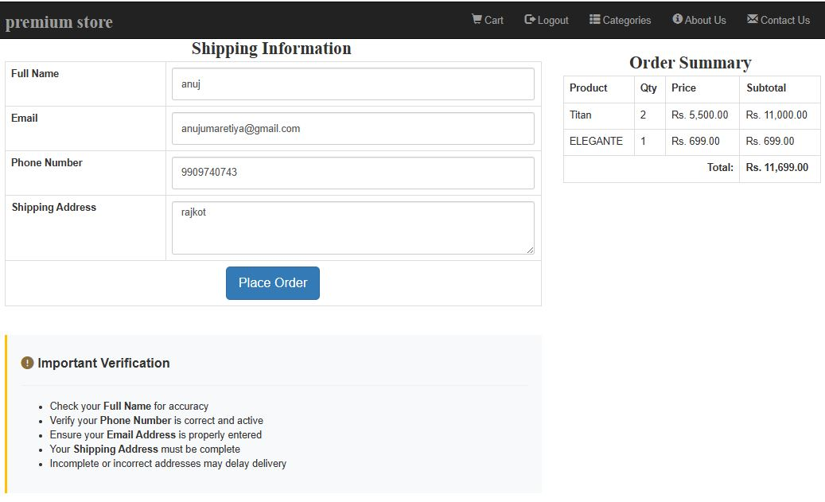
Bill:

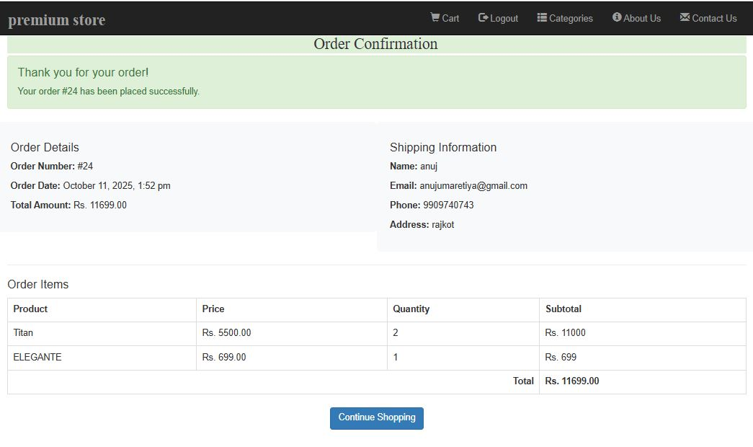

Premium store
46

footer:


43Premium Store
47



This is the most crucial phase in the software development cycle. The developed application is thoroughly tested. Testing procedures and requirements differ with the nature of the product. It basically involves running through the whole application and verifying that the functionality is as per the designs.
: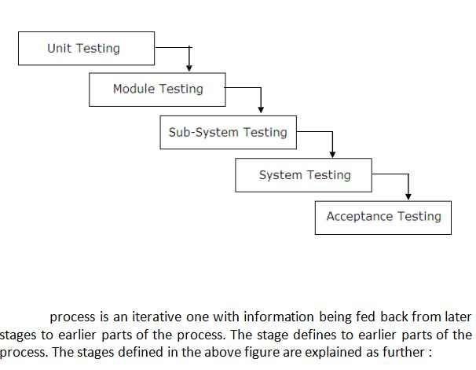

Premium Store
48

Module Testing

A module is a collection of dependent components. A module encapsulates related components so that it can be tested without other system modules. In this project, one module is their, which contains a procedure, which is used by the project.

Sub-System Testing

This phase involves testing of collection of modules, which have been integrated into sub-systems. In this project, public module is, which is used by the project.

System Testing

The sub-systems are integrated to make the entire system. This testing process is concerned with finding errors, which normally results from unanticipated interaction between sub-system and components.

Acceptance Testing

This is the final test in the testing process before the system is accepted for operational use, some times called alpha testing. This process states whether the project satisfies all requirements specified by the customer or not.

49 Premium Store



We are creating this project initial stage of our currier. To complete this project we refer books and website to learn many topics. Those are very useful to create this project. We use following books and websites :

Books
PHP, MySql WebSites
Website : www.premiumstore.com
Website: http://www furniture
.




50

34 46

